Report Title: Artificial Intelligence & Machine Learning - Task 1
Project: Building & Evaluating a Linear Regression Model (House Price Predictor)
Name: Adhiraj Tyagi
Institution: MIET
Date: June 21, 2026

Deliverable : The Project Report
1. Objective and Introduction
The primary objective of this task was to construct and evaluate a Linear Regression model capable of predicting house prices. Utilizing the California Housing dataset, this project encompasses the end-to-end machine learning lifecycle, including data loading, exploratory data analysis (EDA), preprocessing, model training, and performance evaluation. This serves as a foundational exercise in understanding predictive modeling and handling real-world datasets.
2. Dataset and Exploratory Data Analysis (EDA)
The model was trained on the California Housing dataset provided by scikit-learn. The target variable for prediction was MedHouseVal (Median House Value).
During the Exploratory Data Analysis phase, the following steps were taken:
- Data Integrity Check: The dataset was checked for missing values. No null values were found, meaning extensive imputation was not required.
- Statistical Summary: The distributions of the features (such as median income, housing age, and number of rooms) were analyzed to understand their scale and variance.
- Correlation Analysis: A correlation heatmap was generated to identify relationships between the independent variables and the target variable. Notably, MedInc (Median Income) showed the highest positive correlation with the median house value, indicating it is the strongest predictor in the dataset.
- 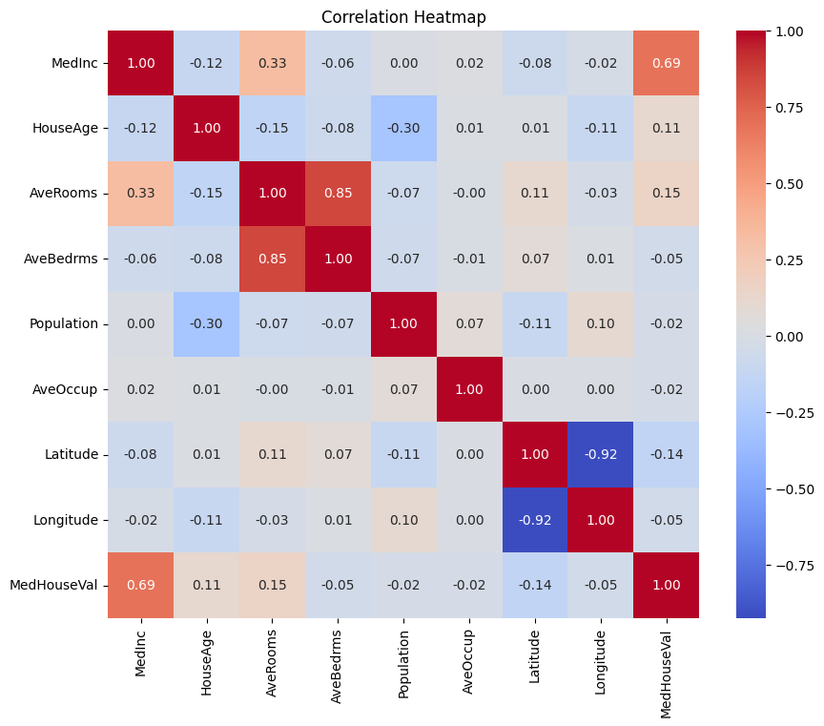
3. Model Methodology
The data was split into training and testing sets using an 80/20 split (test_size=0.2) with a fixed random state (random_state=42) to ensure reproducibility.
A standard Linear Regression algorithm was selected for this baseline task. The model was trained on the 80% training subset, allowing it to learn the linear coefficients that best map the input features to the target housing prices.
4. Evaluation Metrics
Once the model was trained, it was tested on the unseen 20% of the data. The model's performance was evaluated using three standard regression metrics:
- Mean Absolute Error (MAE): 0.533 (This indicates the average magnitude of the errors in a set of predictions, without considering their direction.)
- Root Mean Squared Error (RMSE): 0.746 (This penalizes larger errors more heavily than MAE.)
- R-squared (R²): 0.576 (This indicates that approximately 57.6% of the variance in the house prices can be explained by the model's inputs.)
5. Visualizations
Analysis: The scatter plot illustrates the relationship between actual and predicted values. While there is a clear positive trend aligned with the red line of perfect prediction, there is noticeable variance, particularly at the higher end of house prices where the dataset caps values at 5.0.
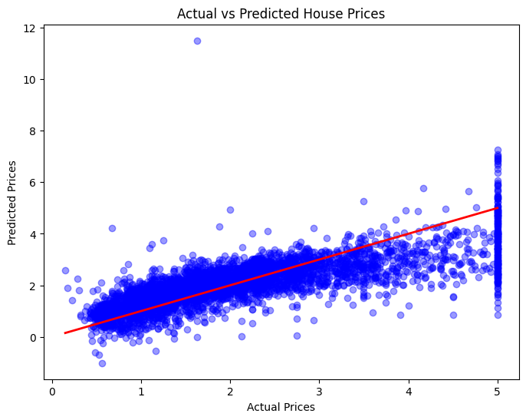

Analysis: The residual distribution is roughly normal and centered around zero, which is a good indicator that the linear regression assumptions are holding, though some outliers exist on the tails.
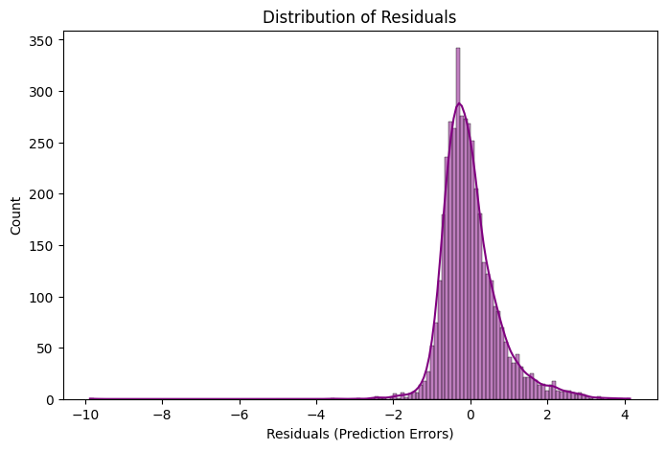

6. Conclusion & Future Improvements
The baseline Linear Regression model successfully captures the general trend of the California housing market, primarily driven by the median income feature. However, an R² score of 0.576 suggests there is significant room for improvement.
Ideas for Future Improvement:
- Feature Engineering: Creating new features, such as combining TotalRooms and Households to get an "average rooms per household" metric.
- Handling Non-Linearity: Applying polynomial regression or log-transforming skewed features to capture non-linear relationships.
- Advanced Algorithms: Experimenting with more robust, tree-based models like Random Forest or Gradient Boosting (XGBoost), which typically perform better on complex, tabular datasets like this one.

